4-1 Journal: Explore Data Structures
Discuss how lists, tuples, and dictionaries in Python are most applicable in your chosen practical application: payroll processing
A real-world example that would involve the use of lists, tuples, and dictionaries is payroll processing and the calculation of employee wages at a small accounting firm. For this example, there will be ten employees in various job positions, some of whom are paid a salary and others who are paid hourly, the payroll will run biweekly so there will be 27 pay periods for 2026. This example will be for period of 4/19/26-5/2/26 (see Figure 1 and 5). The program will need to use several different data containers: lists, tuples, and dictionaries to keep track of each employee’s information and calculate the various components of payroll. For simplicity the payroll calculation will not involve any pre-tax deductions like medical deductibles and traditional IRA contributions, and the additional 0.9% Medicare tax for individuals with income above $200,000 and SUTA will not be calculated to simplify the demonstration. Additionally, no hourly employees will have worked overtime for pay and a half.

Explain the advantages and disadvantages of using each data structure in your chosen practical application:
Lists: a list was utilized to store the input from when the user is prompted to enter the total hours worked by each hourly employee (Interns and Admin) during the payroll period (see Figure 2.1). The advantages of lists are that they are easy to create and easy to change using various methods to add and remove data or modify an existing list. In this scenario, if the user accidentally entered the incorrect hours for a given employee, they could use that employee’s index in the list and update the hours they worked for a given payroll period. A disadvantage of this list is that the values from the list must be mapped to the correct employees, and this would need to be checked for mapping accuracy any time changes are made to the employee listing.
Tuples: since tuples are immutable, meaning that they cannot be changed, the payroll salary and hourly rates for the given positions will be recorded in a tuple. This leads to the advantage that the pay rates cannot be inadvertently changed either by accident or by an employee trying to commit fraud. They will be updated quarterly so the calculations will need to be updated to reflect the updated payroll rates (see Figure 3.1). A disadvantage is that tuples do not allow for mapping of the data to specific employees, leading to the salary and hourly rates information being recorded in the tuple referenced above is incorporated into the dictionary allowing for the immutability of the salary and hourly rates and the key and value matching of the dictionary container (see Figure 4.1).
Dictionaries: since dictionaries allow the connection of information and can be changed, they will be utilized to store the employee’s information: name, job title, payroll type, federal income tax withholding percentage, and state income tax withholding percentage. The key-value pairs of the dictionary are essential and is the chief advantage of using a dictionary in this scenario since the information being recorded is solely based on the individual employee and can vary greatly from employee to employee. They each need a unique identifying number to be able to distinguish each employee as well as the payroll information regarding their level within the company and whether they are paid a salary or are an hourly employee. The mutable aspect is also essential since in order for the payroll calculation to be correct the program user must be able to add additional employees (using the .update method) or reflect the termination of the employees (using del or the .pop method). Additionally, an employee’s job title can change if they are promoted within the organization (using the .update method). Finally, the federal withholding needs to also be changeable since an employee can file an updated W-4 to change the amount of federal withholding from the paycheck; a change can also be made to the amount of the applicable state income tax withholding being removed from the employee’s net pay (using the .update method). A disadvantage of dictionaries in this scenario is maintenance required to keep the dictionary of the employee information accurate. The user would need to ensure that the information stored in the employee information dictionary has been updated prior to running payroll and that no errors have been made in the linking of the salary and hourly wages tuple to the dictionary.

Discuss any challenges that could be encountered when applying each data structure in your chosen practical application:
The example wasn’t as complex as the payroll processing for companies that employee hundreds or thousands of employees, which would require a larger dictionary to store all of the employee information. Additionally, the payroll calculations can be more complicated when considering the Social Security wages cap of $184,500 which is adjusted annually for inflation and there is an additional Medicare tax of 0.99% on high income earners. Calculating these taxes would necessitate tracking of the cumulative wages of the various employees to see if these conditions were met. This would necessitate the storing of more information about each employee which could lead to the employee information dictionary becoming much larger and more difficult for a user to read and understand. The tuple storing the salary and hourly pay rates aspect could also become more difficult in that there could be more categories of annual salaries based on years with the company; years of experience; or additional certifications like a CMA, CBVA, or EA.

Figure 1: Python Code Example
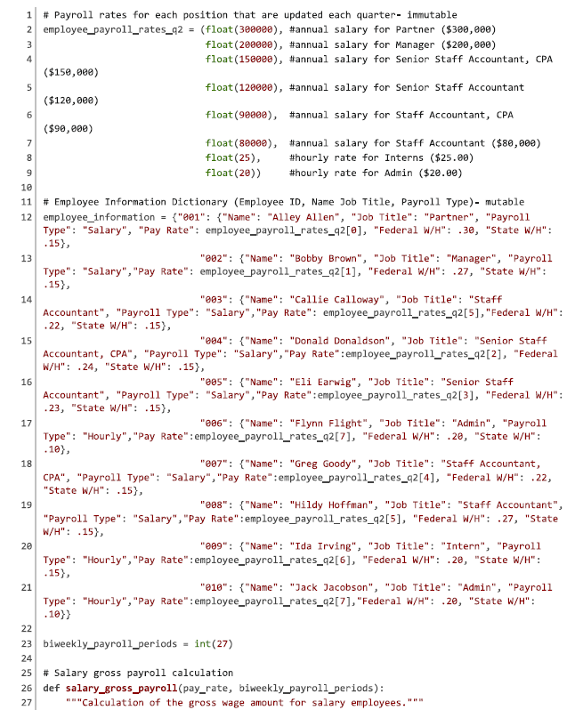
Figure 1: Python Code Example (Continued)
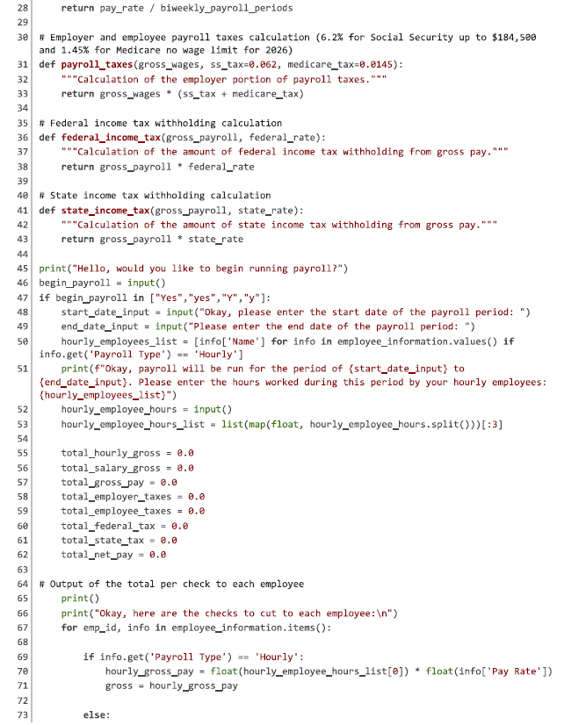

Figure 1: Python Code Example (Concluded)
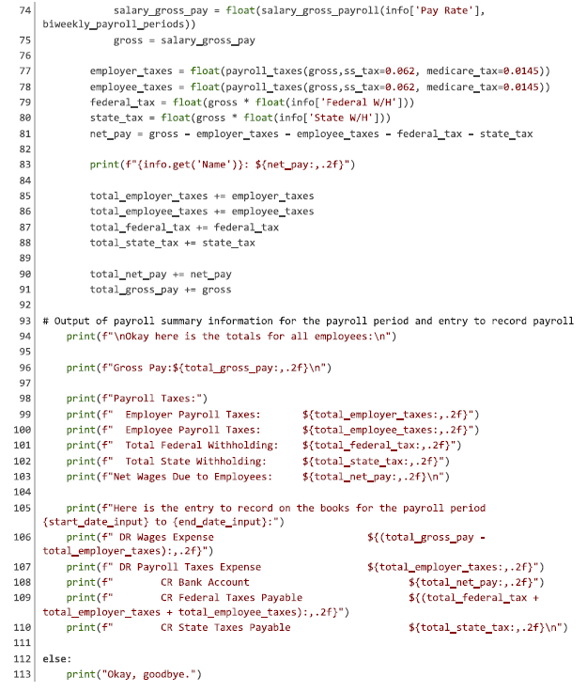

Figure 2: List Excerpts

Figure 2.1: List Created from User Hours Worked Input

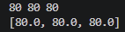

Figure 3: Tuples Excerpts

Figure 3.1: Salary and Hourly Wages Tuple
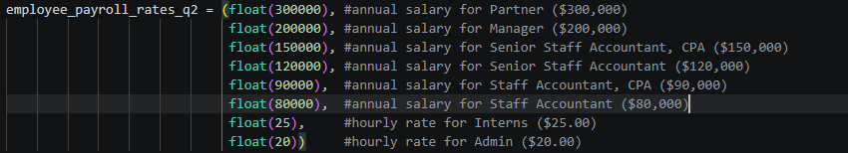

Figure 4: Dictionary Excerpts

Figure 4.1: Importing data from Tuple to Dictionary

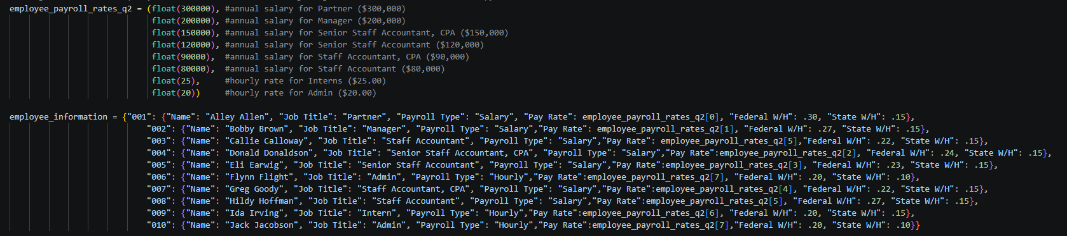

Figure 5: Python Code Terminal Output
